|  |  |
| --- | --- |
| **Name**: AKSHANSH KAUNDAL | **UID**:23BCS13369 |
| **Branch**: CSE | **Section**: 23 BCS_FS 622-B |
| **Semester**: 5 | **Date of Performance**: 09/10/2025 |
| **Subject**: FULL STACK-LAB | **Subject Code**: 23CSP-339 |

**Mongo db 1:**

const express = require('express'); const mongoose = require('mongoose'); const bodyParser = require('body-parser');

const app = express(); app.use(bodyParser.json());

mongoose.connect('mongodb://localhost:27017/productsDB', { useNewUrlParser: true, useUnifiedTopology: true

})

.then(() => console.log('MongoDB connected'))

.catch(err => console.log(err));

const productSchema = new mongoose.Schema({ name: { type: String, required: true }, price: { type: Number, required: true }, category: { type: String, required: true }

});

const Product = mongoose.model('Product', productSchema);

app.post('/products', async (req, res) => { try { const product = new Product(req.body); const savedProduct = await product.save(); res.status(201).json(savedProduct);

} catch (err) { res.status(400).json({ message: err.message });

}

});

app.get('/products', async (req, res) => { try { const products = await Product.find(); res.status(200).json(products);

} catch (err) { res.status(500).json({ message: err.message });

}

});

app.put('/products/:id', async (req, res) => { try {

const updatedProduct = await Product.findByIdAndUpdate( req.params.id, req.body,

{ new: true }

);

if (!updatedProduct) return res.status(404).json({ message: 'Product not found' }); res.status(200).json(updatedProduct);

} catch (err) { res.status(400).json({ message: err.message });

}

});

app.delete('/products/:id', async (req, res) => { try {

const deletedProduct = await Product.findByIdAndDelete(req.params.id); if (!deletedProduct) return res.status(404).json({ message: 'Product not found' }); res.status(200).json({ message: 'Product deleted', product: deletedProduct

});

} catch (err) { res.status(500).json({ message: err.message });

}

});

const PORT = 3000; app.listen(PORT, () => console.log(`Server running on port

${PORT}`));

Expected output:

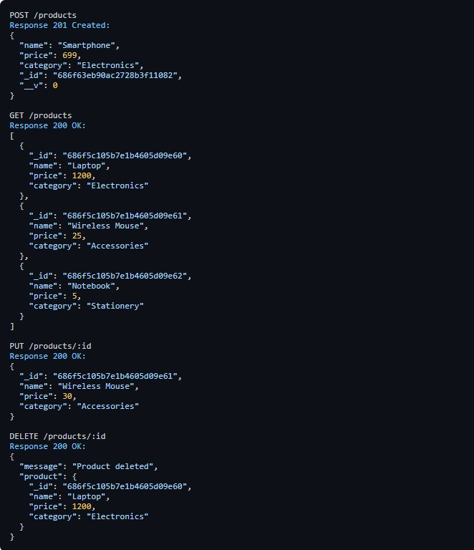

Mongo db 2:

Project Structure

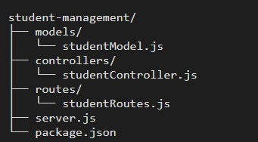

**server.js**

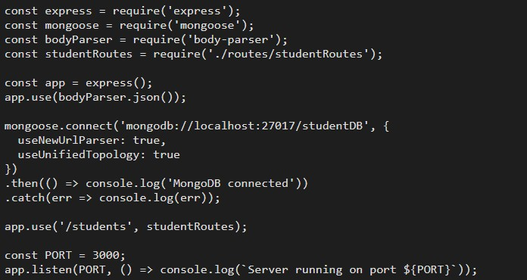

**Models/studentModel.js**

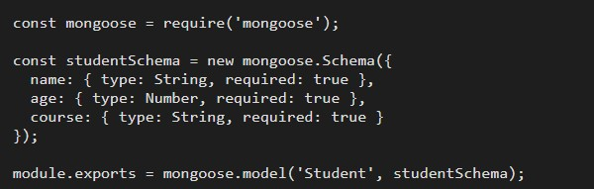

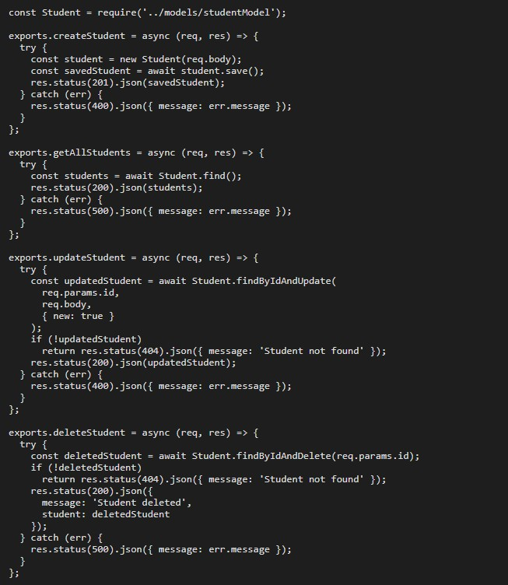**Controllers/studentController.js Routes/studentRoutes.js**

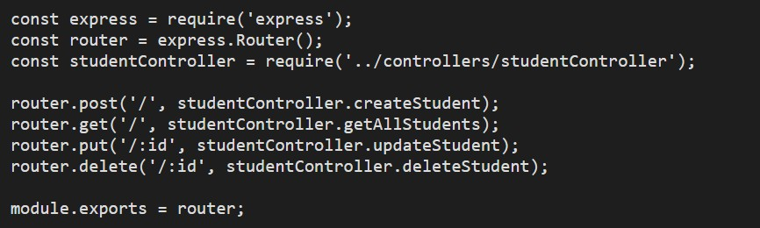

**Expected Output (Postman Style):**

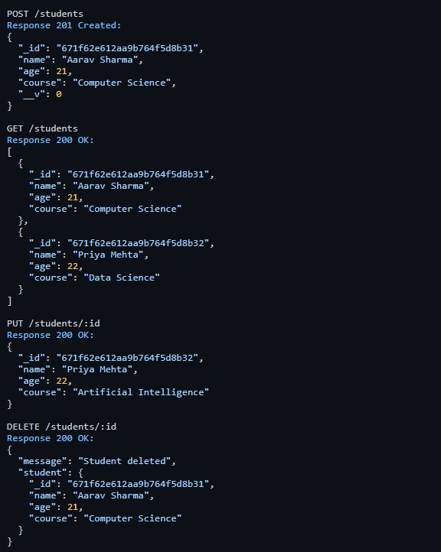

**Mongo db 3:**

**use ecommerceDB; db.createCollection("products");**

**db.products.insertMany([**

**{**

**name: "Smartphone", price: 699, category: "Electronics", variants: []**

**},**

**{**

**name: "Winter Jacket", price: 200, category: "Apparel", variants: [**

**{ color: "Black", size: "S", stock: 8 },**

**{ color: "Gray", size: "M", stock: 12 }**

**]**

**},**

**{**

**name: "Running Shoes", price: 120, category: "Footwear", variants: [**

**{ color: "Red", size: "M", stock: 10 },**

**{ color: "Blue", size: "L", stock: 5 }**

**]**

**}**

**]);**

**db.products.find().pretty();**

**db.products.find({ category: "Electronics"**

**}).pretty();**

**db.products.find({ "variants.color": "Blue"**

**}).pretty();**

**db.products.find({}, { name: 1,**

**"variants.color": 1, _id: 0 }).pretty();**

**db.products.updateOne( { name: "Running Shoes",**

**"variants.color": "Blue" },**

**{ $set: { "variants.$.stock": 8 } }**

**);**

**db.products.deleteOne({ name:**

**"Smartphone" });**